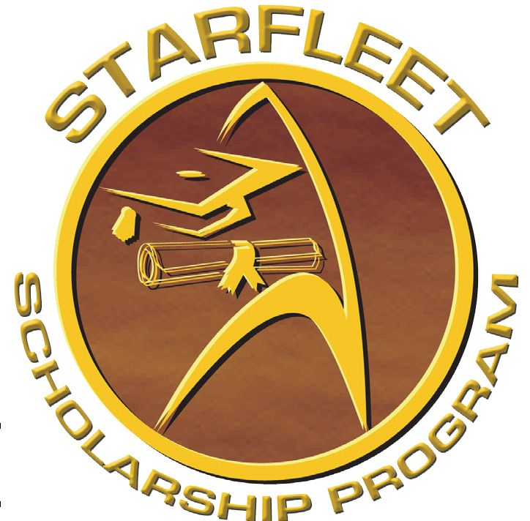STARFLEET SCHOLARSHIP PROGRAM

We Want YOU!
All NON-STARFLEET members are eligible to apply for one of two (2) scholarships to help you continue or begin your studies at community colleges, four-year colleges, most technical schools, junior colleges, universities, graduate schools, or any other accredited institution/organization that offers a certificate/diploma or degree program. The scholarships may be split each year, half going for the fall semester and the remaining half for the spring. (If your school does not run on a traditional calendar, note that on the application.)
The application period runs from January 1 until June 1 each year. All scholarships will be announced via all STARFLEET’s communications platforms by August 1st. After the announcement has been made, the scholarship award winners will be notified, and checks will be mailed directly to the schools to be used toward tuition, books, fees, loans, and/or other school necessities. All applications must be received by June 1st - the Application Deadline.
Simply submit your completed application packet (this form, your essay, references, and transcripts (or proof of acceptance if it is your first year of higher education)) to the Scholarship Director, Rob Hunnicutt, by sending the application in one of the following ways:
Electronic Mail: Scan and send your completed application packet to scholarships@sfi.org
Postal Mail: Mail your completed application packet to: Rob Hunnicutt, Director
STARFLEET Scholarship Program
19630 Tularosa Ln.
Tomball, TX 77377
The contents of your COMPLETED application packet should include:
- The STARFLEET Scholarship Application Form filled out in its entirety.
- A two-page personal essay addressing the topics involved with the scholarship you are applying for (Women in STEM or IDIC)
- Two (2) letters of recommendation with signatures from the persons making the recommendation. These recommendations can be made by teachers, administrators, guidance counselors, academic advisors, professors, employers, and other community or volunteer leaders.
- An official copy of your latest transcript. If your school needs a written request from the scholarship office, contact the director ASAP
- If you are currently in high school going into college, you need to include a copy of your acceptance letter.

What are the Scholarships?
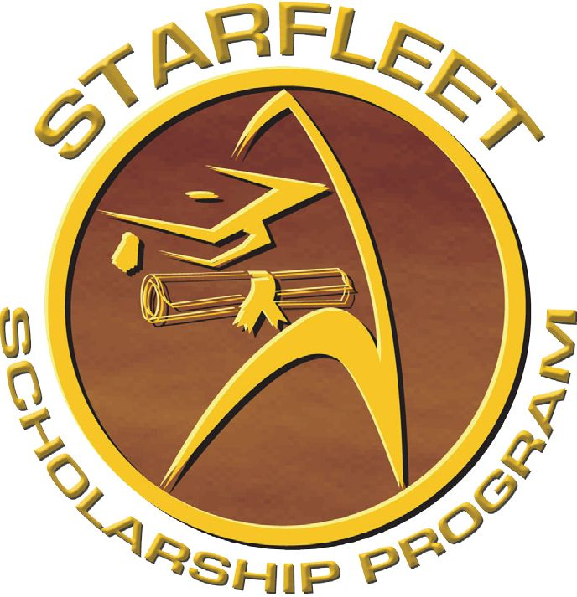For the upcoming school year, we have two (2) distinct scholarship categories. Each category may award a scholarship of an amount dependent on the available funds for that year. The scholarship categories are as follows:
Scholarship for Women Pursuing a Degree in Science, Technology, Engineering, and Mathematics – This scholarship is available to women that are pursuing a degree in a STEM field. Applicants must submit proof of acceptance to a higher education program to be considered for this scholarship. Fill out the application form below and submit a 1–2-page essay discussing goals you intend to pursue with a career in STEM and why you are the best candidate for this scholarship. Submit application packets to scholarships@sfi.org.

Russell Camp III Memorial Diversity Scholarship – This scholarship is awarded to an applicant that has exemplified diversity through actions while pursuing a degree in higher education. Applicants must submit proof of acceptance to a higher education program to be considered for this scholarship. Fill out the application form at the link below and submit with it a 1–2-page essay discussing why IDIC is important to you, any accomplishments you have made in your work to promote IDIC, and why you are the best candidate for this scholarship. Submit application packets to scholarships@sfi.org.
STARFLEET
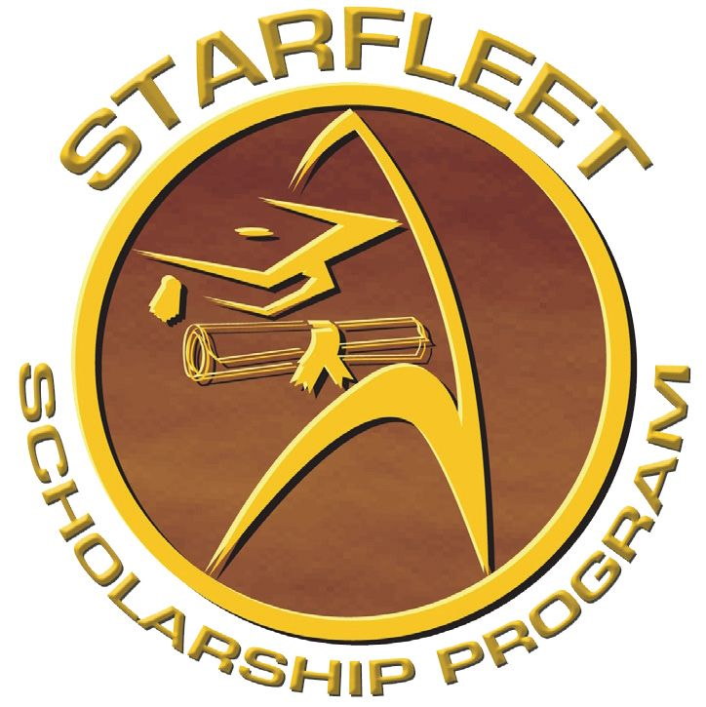SCHOLARSHIP
APPLICATION
Applicant’s Personal Information
Name: |  | Date of Birth:
Address: |  | Phone:
City: State/Province: |  | Zip/Postal Code: | Country:
Email Address:
Applicant's Educational Information
Scholarship being applied for:
Type of Institute scholarship is intended for (i.e.: vocational, 4-year college/university, junior college, etc.):
Name of Institute:
Are you Currently Attending? | Accepted? (if not currently attending)
Highest level of education completed as of June 1:
Major or Field of Study:
Most current GPA: | Student Number (if currently attending):

I certify that the information contained within this application packet is accurate to the best of my knowledge.
_________________ Signature of Applicant ____________________________________
Date

