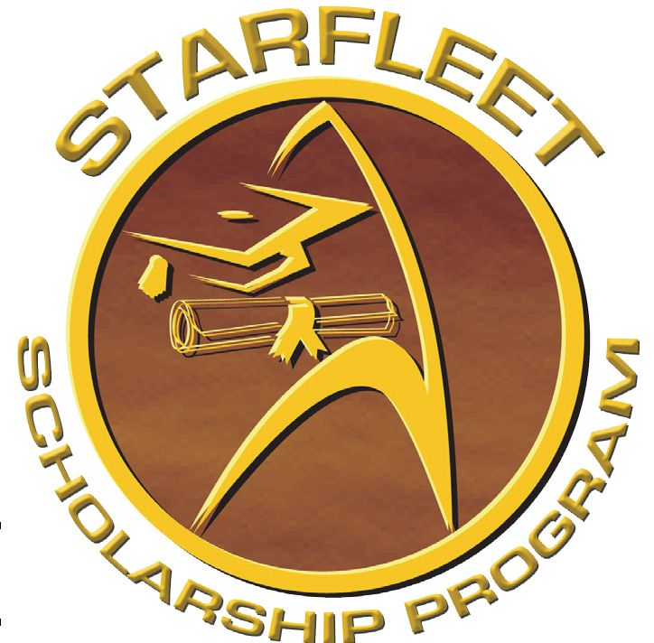STARFLEET SCHOLARSHIP PROGRAM

We Want YOU!
All STARFLEET members who have been in STARFLEET for at least one calendar year prior to the Application Deadline (June 1st) are eligible to apply for one of five (5) scholarships to help you continue or begin your studies at community colleges, four-year colleges, most technical schools, junior colleges, universities, graduate schools, or any other accredited institution/organization that offers a certificate/diploma or degree program. The scholarships may be split each year, half going for the fall semester and the remaining half for the spring. (If your school does not run on a traditional calendar, note that on the application.)
The application period runs from January 1 until June 1 each year. All scholarships will be announced via all of STARFLEET’s communications platforms by August 1st. After the announcement has been made, the scholarship award winners will be notified, and checks will be mailed directly to the schools to be used toward tuition, books, fees, loans, and/or other school necessities. All applications must be received by June 1st - the Application Deadline.
Simply submit your completed application packet (this form, your essay, references, transcripts and employment history) to the Scholarship Director, Rob Hunnicutt, by sending the application in one of the following ways:
Electronic Mail: Scan and send your completed application packet to scholarships@sfi.org
Postal Mail: Mail your completed application packet to: Rob Hunnicutt, Director
STARFLEET Scholarship Program
19630 Tularosa Ln.
Tomball, TX 77377
The contents of your COMPLETED application packet should include:
- The STARFLEET Scholarship Application Form filled out in its entirety.
- A two-page personal essay addressing the following items in detail: (1) Why are you applying for this scholarship? (2) What STARFLEET activities are you involved in? and (3) Other activities you participate in such as academic, athletic, interscholastic, non-STARFLEET interests, career-related, volunteer opportunities, etc.
- A brief employment history, if any. If you have not worked, please include a resume of any volunteer activities you have performed.
- Two (2) letters of recommendation with signatures from the persons making the recommendation. These recommendations can be made by teachers, administrators, guidance counselors, academic advisors, professors, employers, and other community or volunteer leaders.
- One (1) letter of recommendation from a member of STARFLEET in good standing that has achieved the rank of Captain or above.
- An official copy of your latest transcript. If your school needs a written request from the scholarship office, contact the director ASAP
- If you are currently in high school going into college, you need to include a copy of your acceptance letter.

What are the Scholarships?
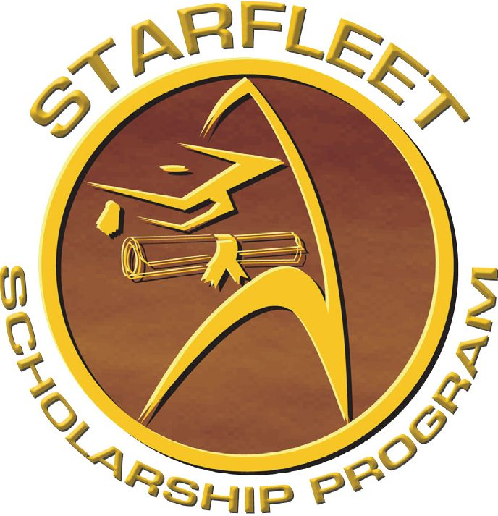For the upcoming school year, we have five (5) distinct scholarship categories (four (4) denoting specific areas of study and one (1) general scholarship for those members who have a major that does not necessarily fit into one of the other categories). Each category may award a scholarship in a dollar amount determined by available STARFLEET funds. The scholarship categories are as follows:

ENGINEERING & TECHNOLOGY - James Doohan/Montgomery Scott Engineering & Technology Scholarship - This very popular scholarship covers any field related to engineering and other fields of study involving technology, computer science, etc.
MEDICINE & VETERINARIAN - DeForest Kelley/Dr. Leonard McCoy Memorial Medical & Veterinarian Scholarship - This is a scholarship for medical studies of both humans and animals and is awarded for programs in medical school, nursing school, physical therapy, pre-med, EMT Paramedic, surgical technician, biomedical technician, and veterinary medicine.
ARTISTIC - Gene Roddenberry Memorial/Sir Patrick Stewart Scholarship for Aspiring Writers & Artists - This is for all those studying acting, dance, music, writing, literature, or for skills and training relating to the media, graphic artists, filmmaking, etc.
BUSINESS/MANAGEMENT/EDUCATION - Armin Shimerman/George Takei/LeVar Burton Scholarship for Business, Language Studies & Education - This scholarship is for business and management studies, the study of foreign languages or studies abroad, and for teaching, and any related field in these areas.
MISCELLANEOUS - Space Explorers' Memorial Scholarship - This scholarship honors the Apollo, Shuttle Challenger, and Shuttle Columbia astronauts and Russian cosmonauts that have died to further our efforts in space exploration. It is a "general duty" scholarship and applies to all courses of study not mentioned in the other 4 scholarships. If a scholarship applicant's field of study does not quite match up with one of the other scholarship types, they may be awarded this one.
STARFLEET
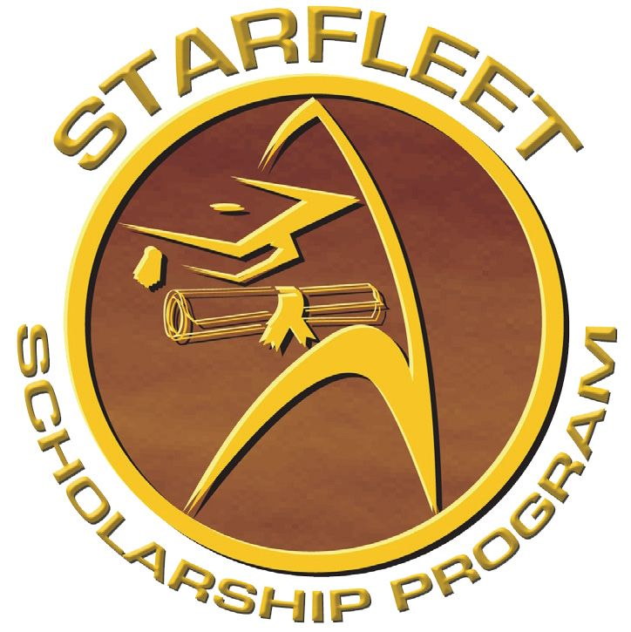SCHOLARSHIP
APPLICATION
Applicant’s Personal Information
Name: |  | SCC No.:
Address: |  | Phone:
City: State/Province: |  | Zip/Postal Code: | Country:
Email Address: | Length of membership in STARFLEET:
Chapter: | Rank:
Applicant's Educational Information
Scholarship being applied for:
Type of Institute scholarship is intended for (i.e.: vocational, 4-year college/university, junior college, etc.):
Name of Institute:
Are you Currently Attending? | Accepted (if not currently attending)?
Highest level of education completed as of June 1:
Major or Field of Study:
Most current GPA: | Student ID Number (if currently attending):

I certify that the information contained within this application packet is accurate to the best of my knowledge.
_________________ Signature of Applicant ____________________________________
Date

